HAMZA PART:
FILIUS COMPUTER NETWORK
NETWORK PICTURE
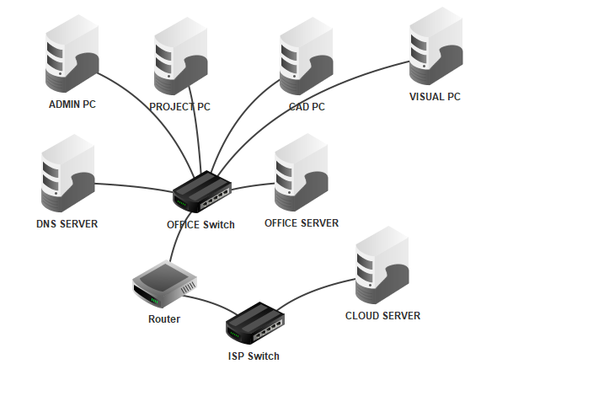

IP ADDRESSING TABLE

Device | IP address | Subnet mask | Default gateway | DNS server
Admin PC | 192.168.10.101 | 255.255.255.0 | 192.168.10.1 | 192.168.10.2
Project PC | 192.168.10.111 | 255.255.255.0 | 192.168.10.1 | 192.168.10.2
CAD PC | 192.168.10.121 | 255.255.255.0 | 192.168.10.1 | 192.168.10.2
Visual PC | 192.168.10.131 | 255.255.255.0 | 192.168.10.1 | 192.168.10.2
DNS Server | 192.168.10.2 | 255.255.255.0 | 192.168.10.1 | 192.168.10.2
Office Server | 192.168.10.10 | 255.255.255.0 | 192.168.10.1 | 192.168.10.2
Router — office interface | 192.168.10.1 | 255.255.255.0
Router — external interface | 203.0.113.1 | 255.255.255.0
Cloud Server | 203.0.113.10 | 255.255.255.0 | 203.0.113.1 | 192.168.10.2
IP ADDRESSING OF EACH
MY PART WAD TO ASSINGN IP ADDRESS THESE ARE THE IP ADDRESSES OF ALL WITH PICTURES .
ADMIN IP :
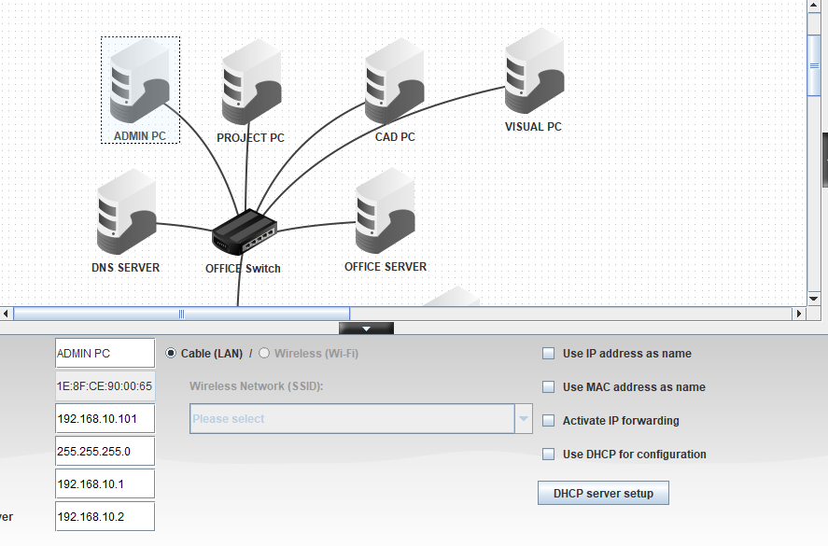
CAD IP :
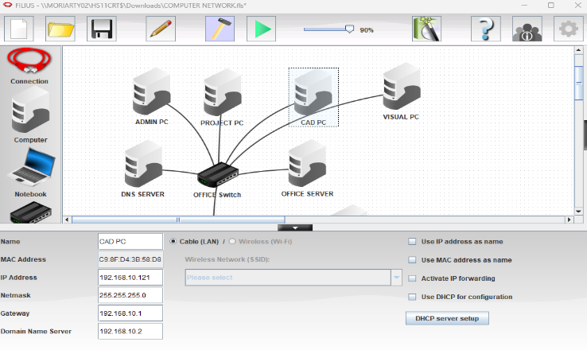
DNS IP :
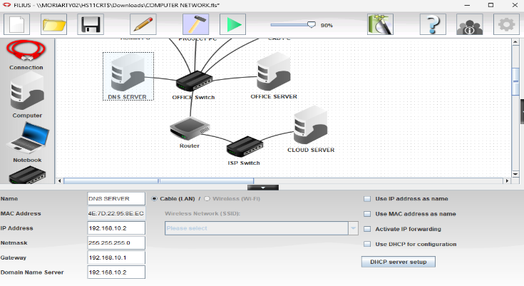
PROJECT IP :
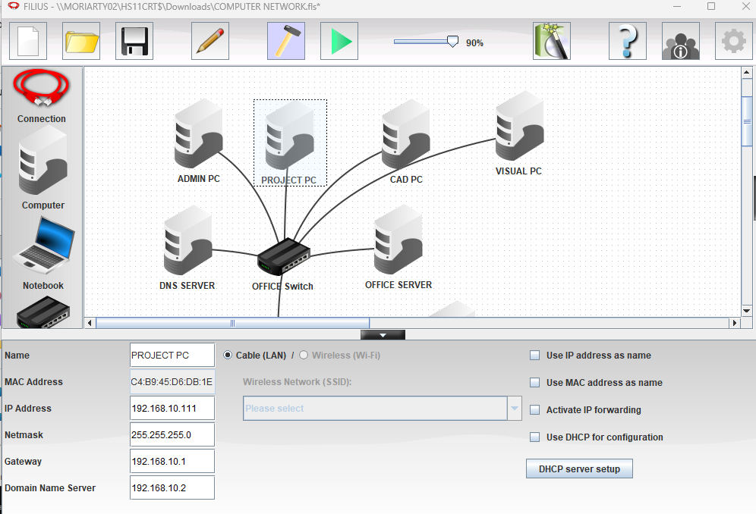
OFFICE IP :
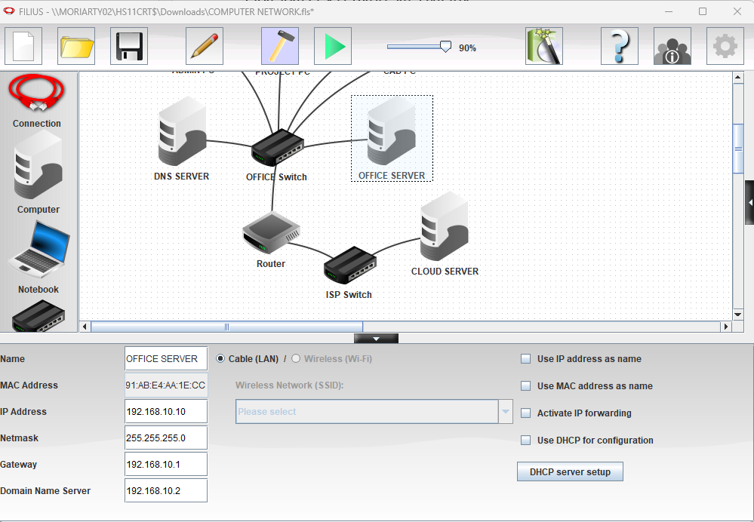
CLOUD IP :
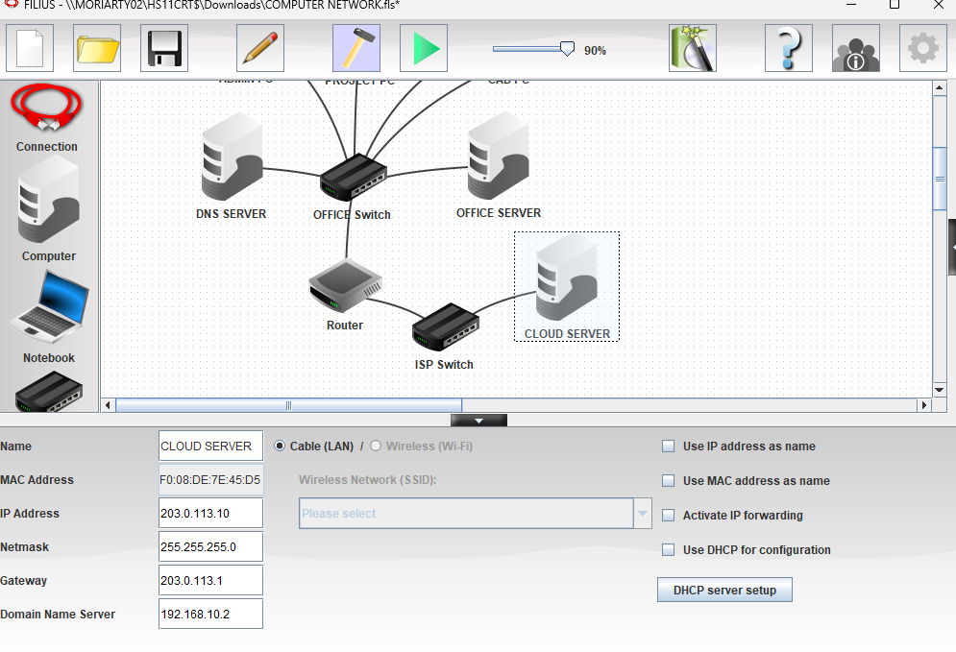
DNS RECORD

Website name | IP address
intranet.archstudio.local | 192.168.10.10
cloud.archstudio.example | 203.0.113.10

PROTOCOLS AND NETWORKING CONCEPTS
Protocol | explanation
IP | Provides logical addresses so packets can be sent to the correct device or network.
DNS | Finds the IP address associated with a website name.
HTTP | Lets a web browser request website content from a web server.
ICMP | Used by ping to test reachability and report network errors.
Ethernet | A common technology used to send data across a wired local area network.
TCP | Provides reliable, ordered delivery of data between applications.
Default gateway | The router interface a device uses to send traffic to other networks.

LAN AND EXTERNAL NETWORK
The LAN is the local network inside the office. It contains four office PCs, a DNS server and an office web server. These devices use addresses in the 192.168.10.0/24 network. The office switch connects local devices, while the router acts as the gateway to another network.
CLIENT SERVER MODEL
In the client-server model, a client requests a service and a server provides it. In this project, the CAD PC is a client when it uses a browser to request a web page. The Office Server hosts the internal company page, and the Cloud Server hosts the external cloud page. The DNS server helps the client find the correct server by translating a website name into an IP address.
TESTING RECORD

Test | Command | Actual result
Ping Admin PC | ping 192.168.10.101 | 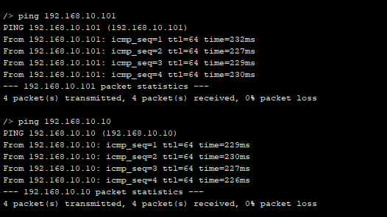
Ping Office Server | ping 192.168.10.10
Ping DNS Server | ping 192.168.10.2 | 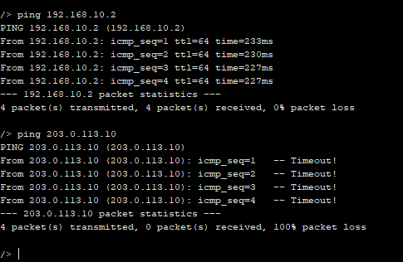
Ping Cloud Server | ping 203.0.113.10
Internal website | http://intranet.archstudio.local | 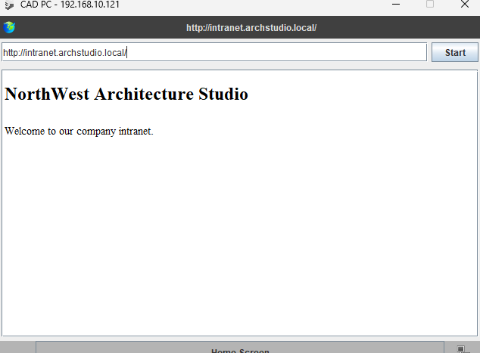
External website | http://cloud.archstudio.example | 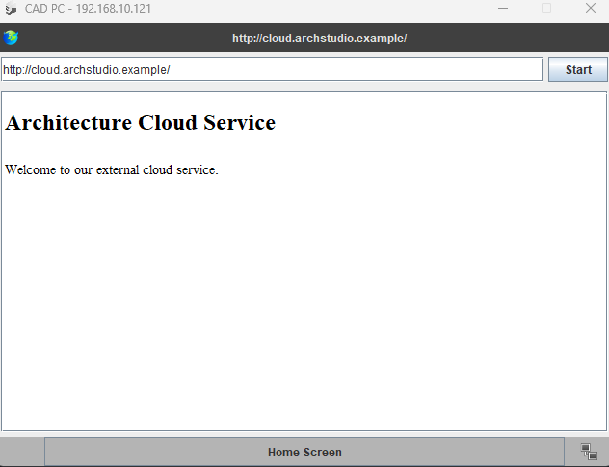

NETWORK TOPOLOGY
ROUTER INTERFACE
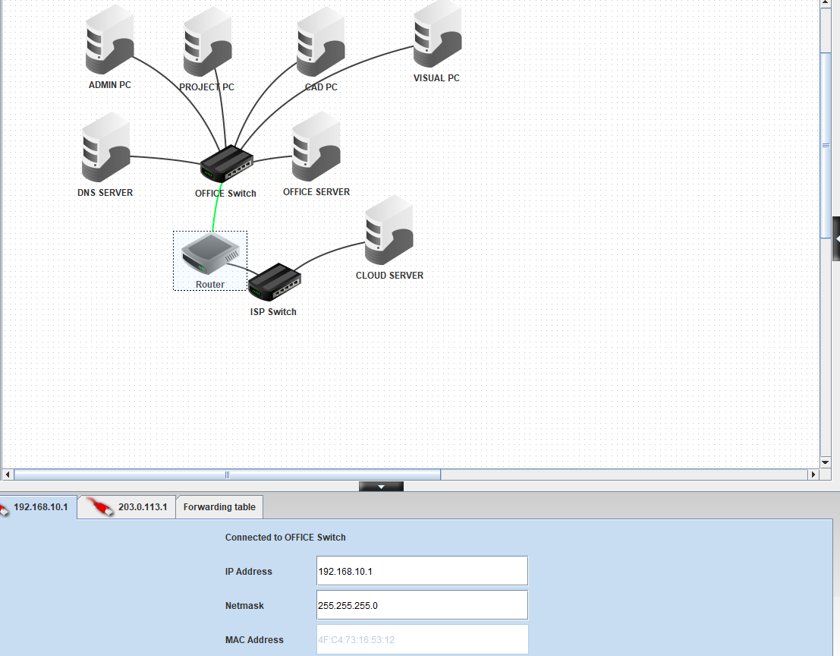
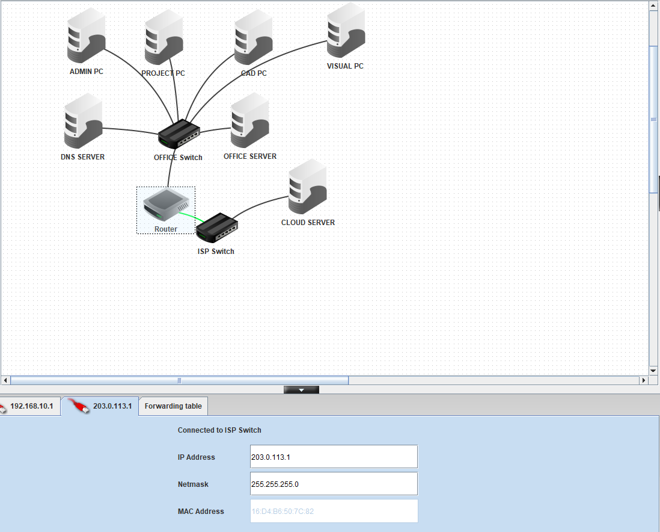

DNS
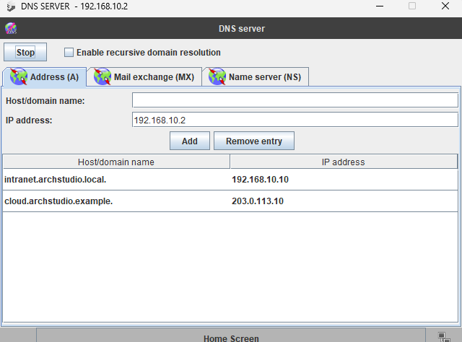

WEBSITE

PING TEST

- SAIRA PART:

- Evidence:
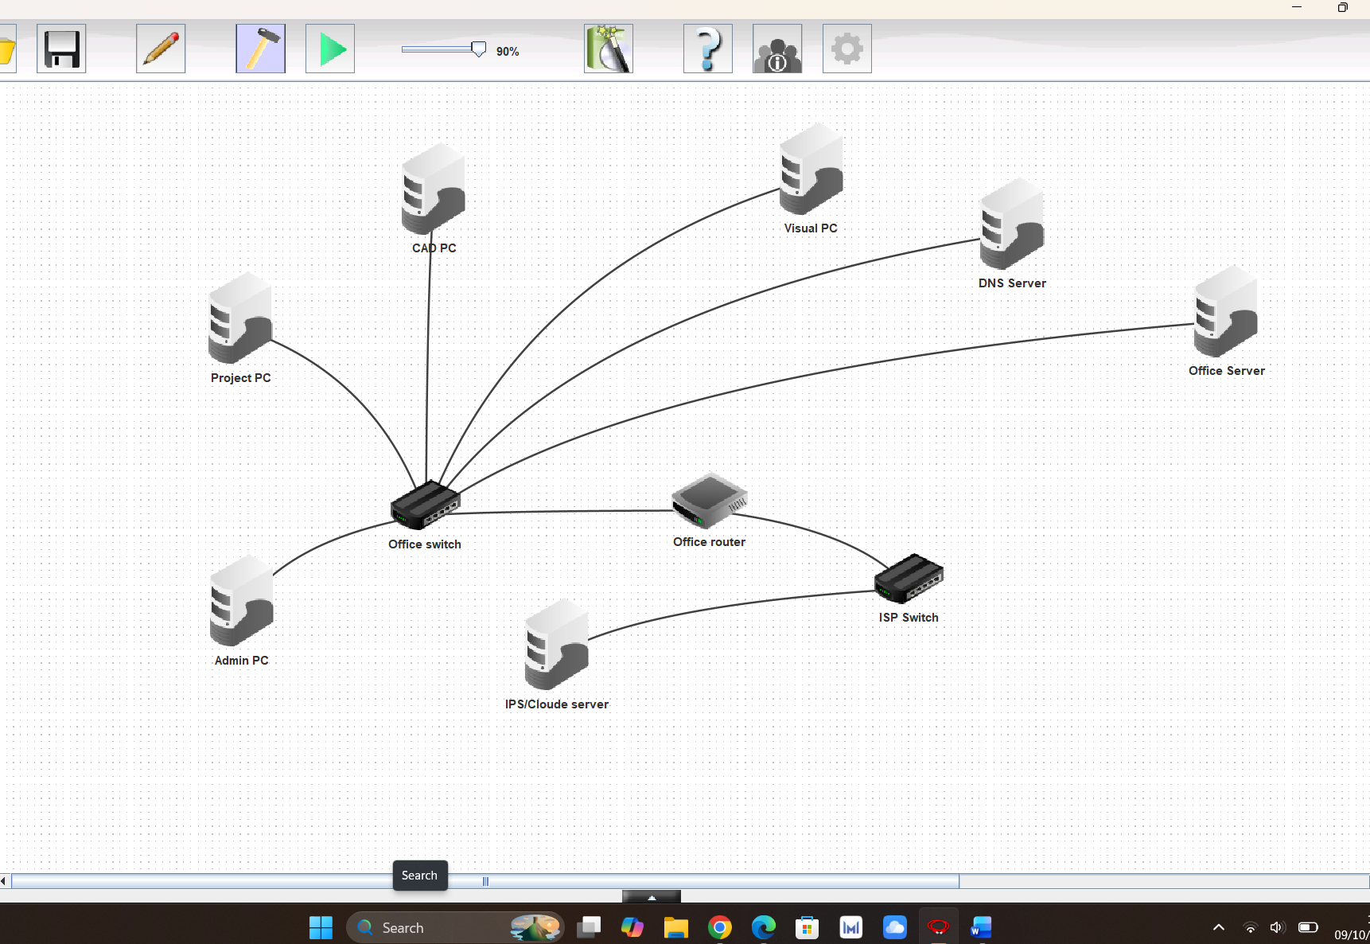

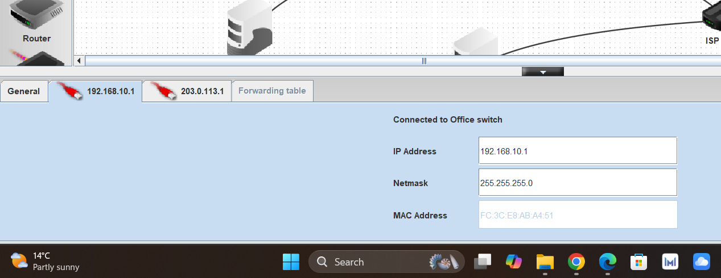
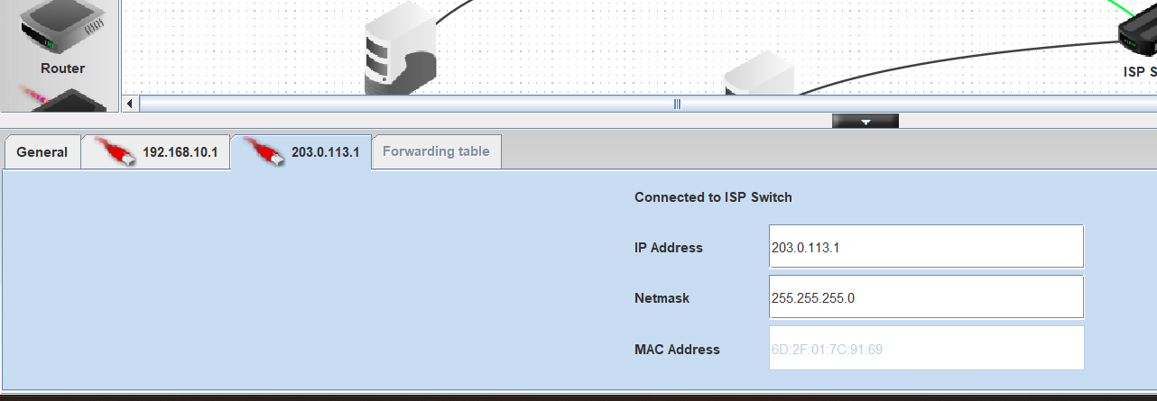
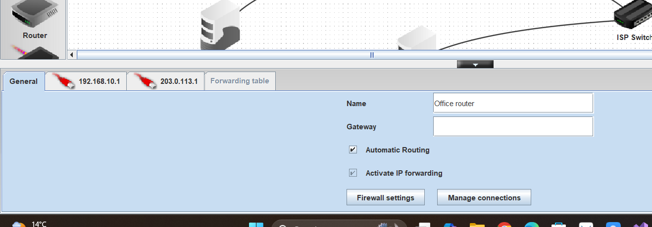

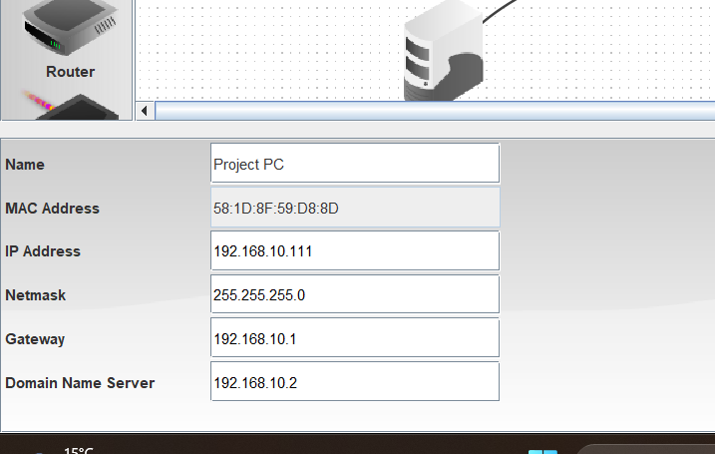
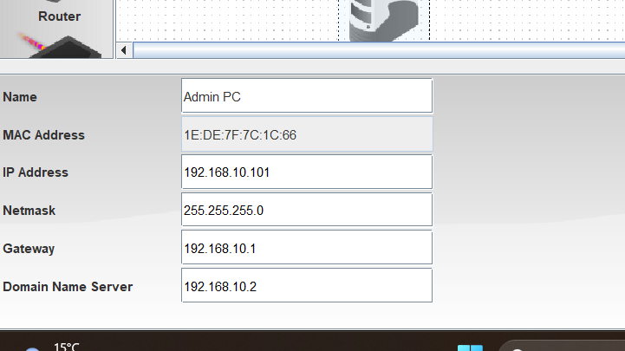
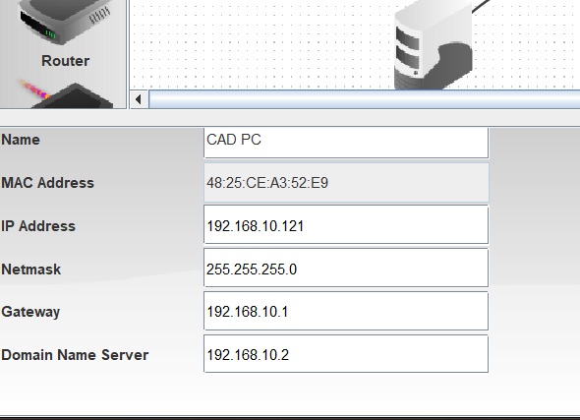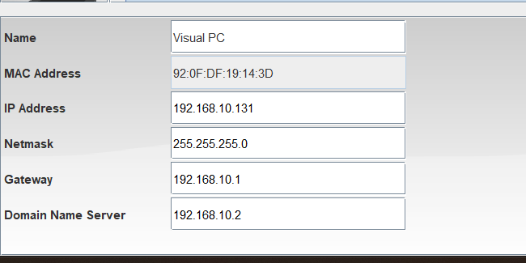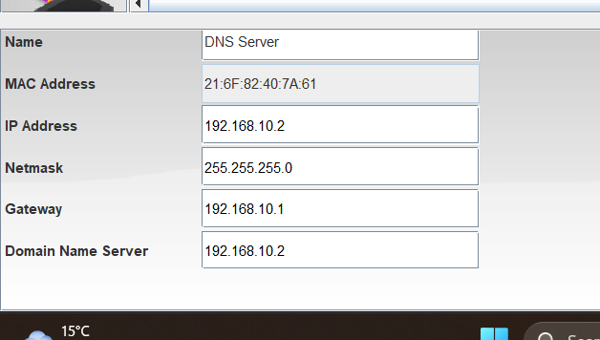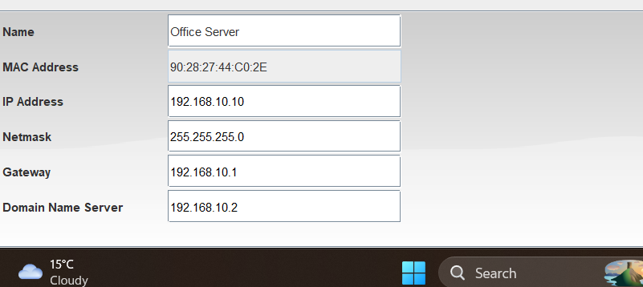
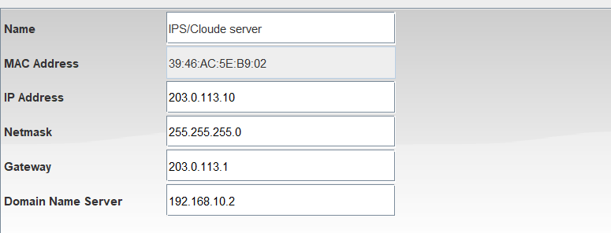
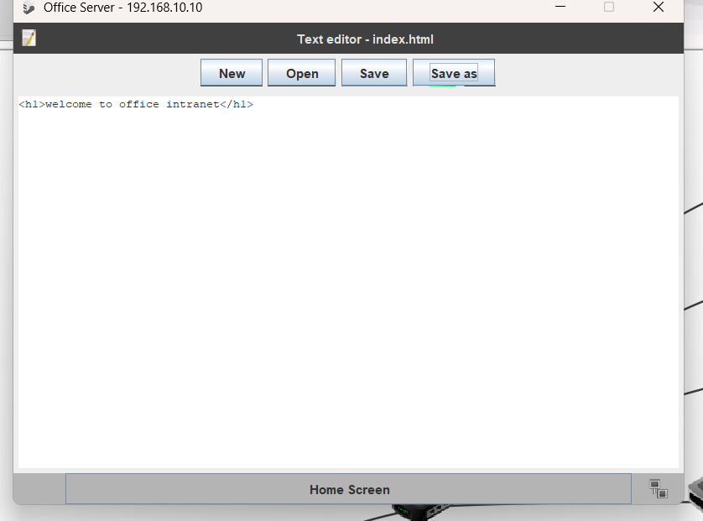
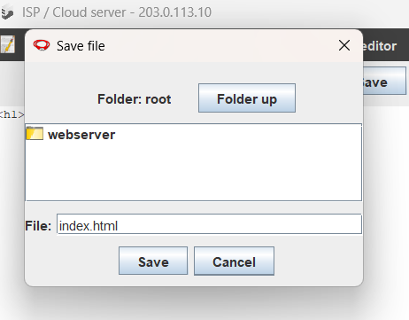
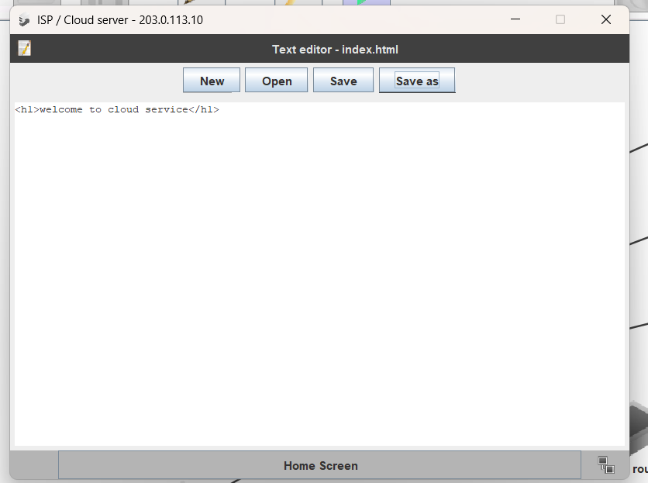
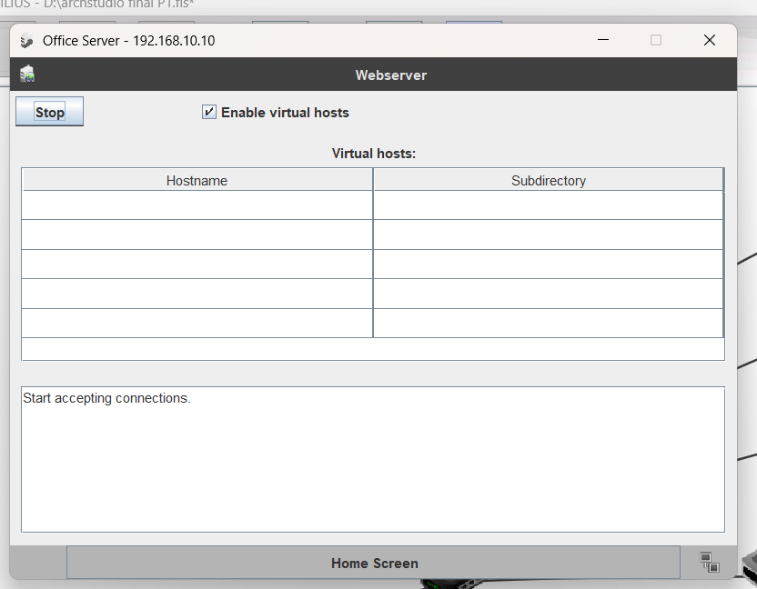
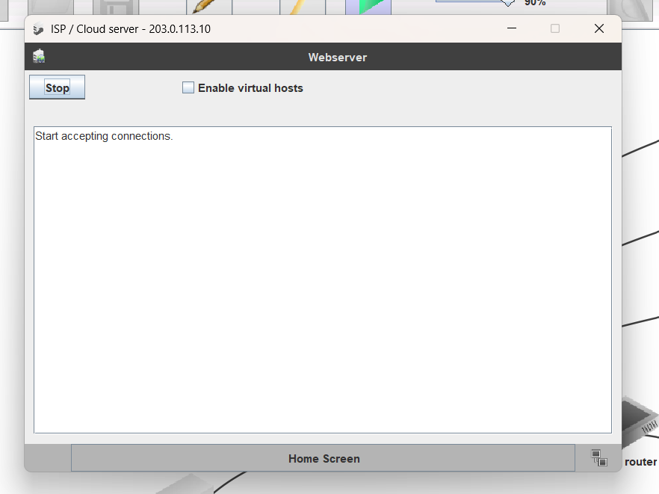
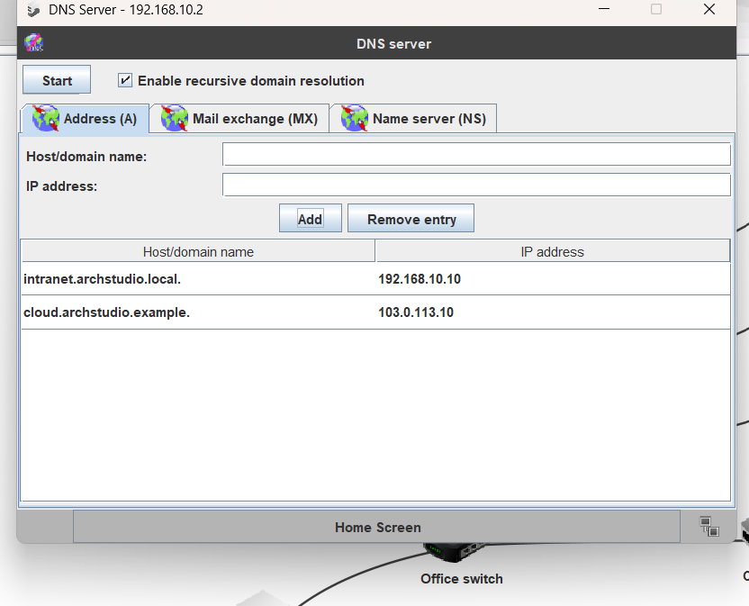
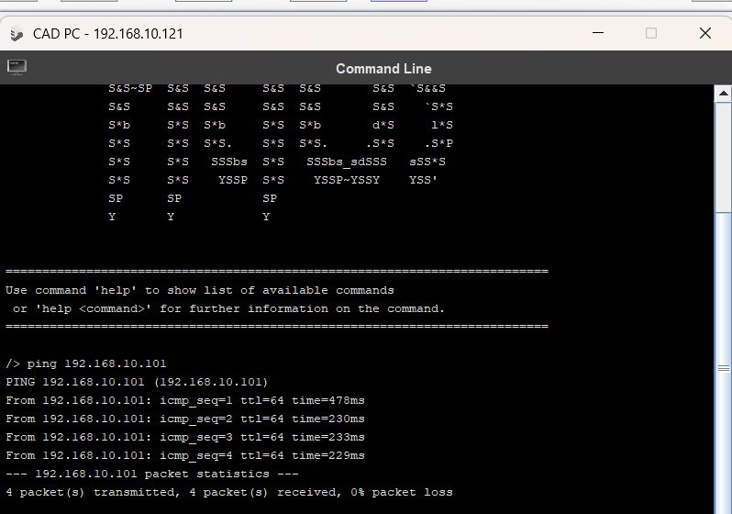
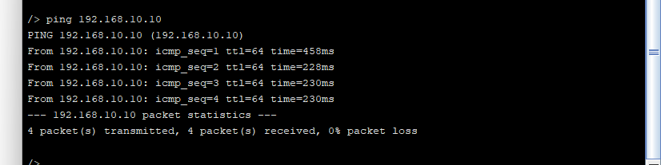
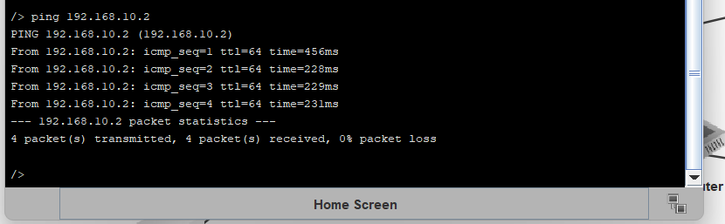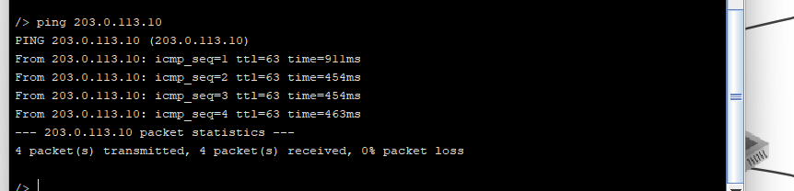

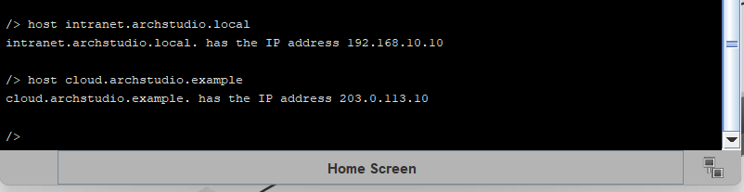
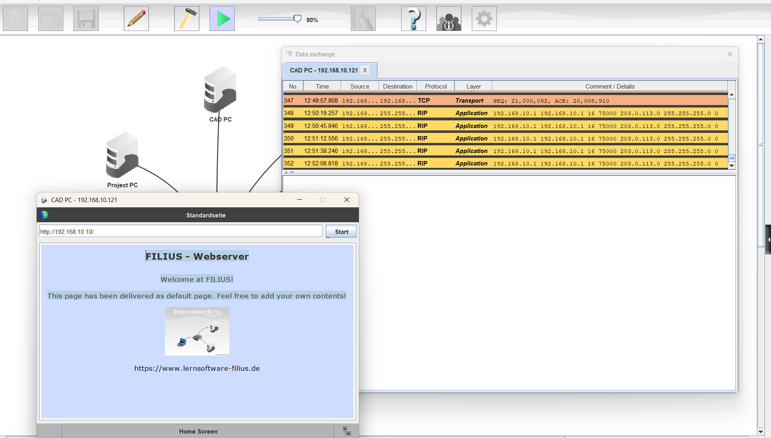
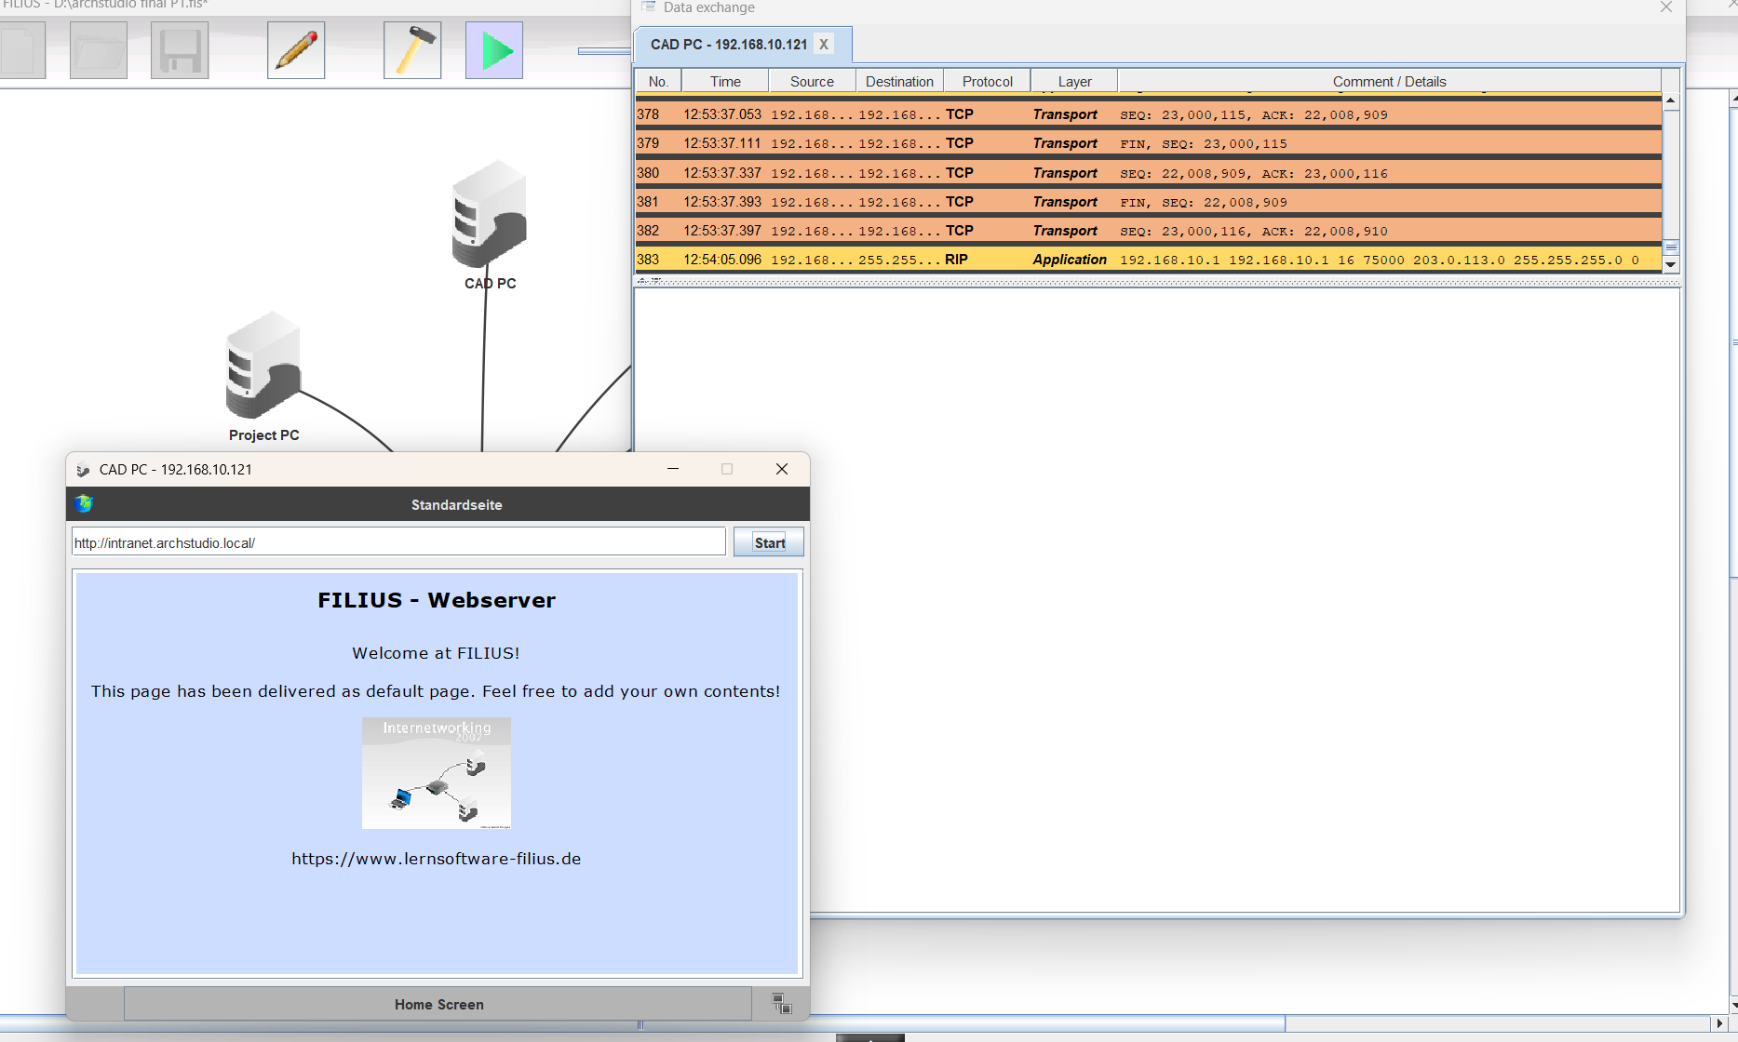
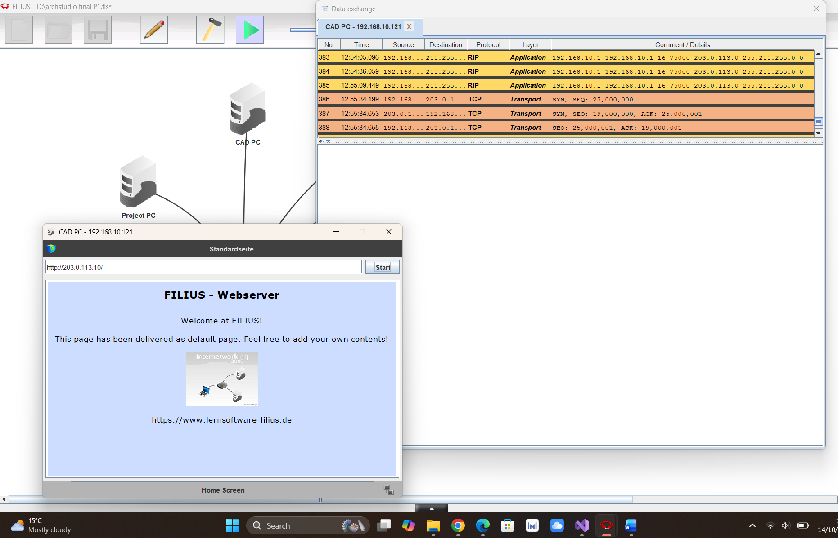
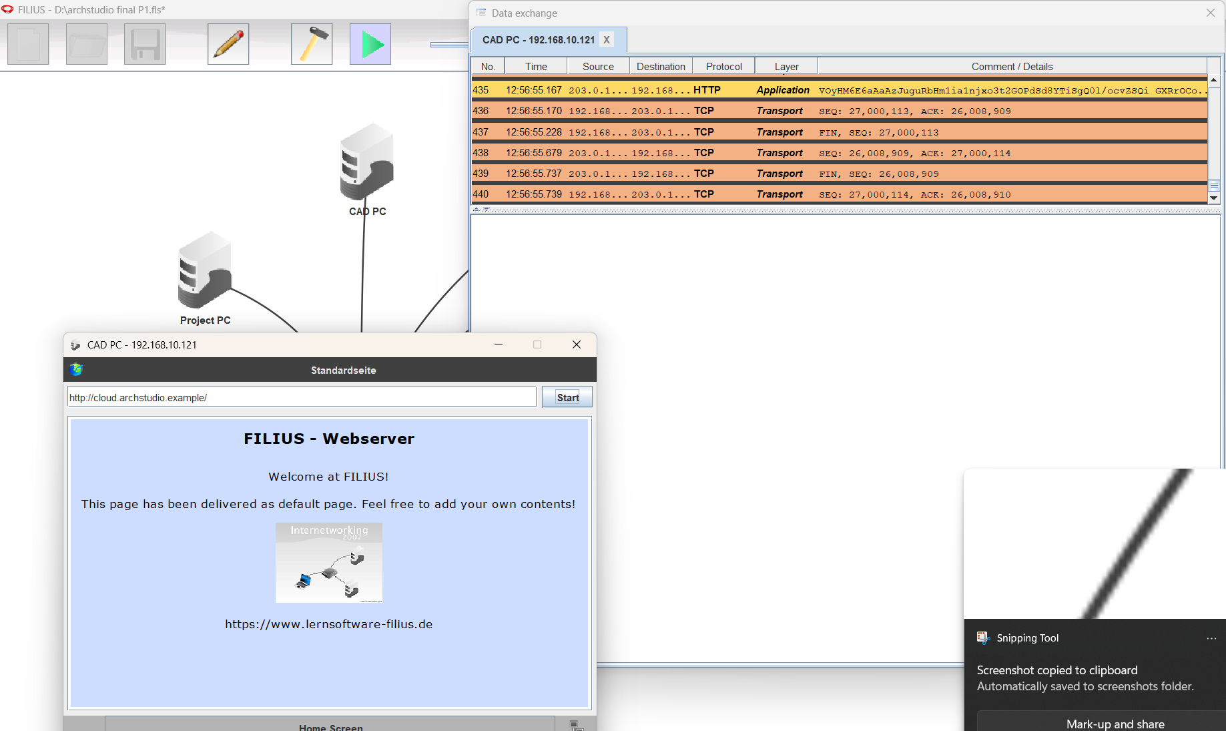

- IP Addressing Table:
Device | IP Address | Subnet Mask | Gateway | DNS
Router (Office side) | 192.168.10.1 | 255.255.255.0
Router (External side) | 203.0.113.1 | 255.255.255.0
DNS Server | 192.168.10.2 | 255.255.255.0 | 192.168.10.1 | 192.168.10.2
Office Server | 192.168.10.10 | 255.255.255.0 | 192.168.10.1 | 192.168.10.2
Admin PC | 192.168.10.101 | 255.255.255.0 | 192.168.10.1 | 192.168.10.2
Project PC | 192.168.10.111 | 255.255.255.0 | 192.168.10.1 | 192.168.10.2
CAD PC | 192.168.10.121 | 255.255.255.0 | 192.168.10.1 | 192.168.10.2
Visual PC | 192.168.10.131 | 255.255.255.0 | 192.168.10.1 | 192.168.10.2
ISP / Cloud Server | 203.0.113.10 | 255.255.255.0 | 203.0.113.1 | 192.168.10.2

- Protocols:

- TCP/IP:
Transmission Control Protocol/Internet Protocol are the rules that make all the connections and are responsible for making conversation between both local and external networks. When a computer sends data, TCP converts this data into small packets and checks that this data is safely sent and then puts it back together at the destination; on the other hand, IP checks that the data is sending to the correct address/destination.

- IP addressing and Subnet mask:
In a specific network, every PC and server has its own unique IP address. And it helps a PC to communicate with another PC. Just like every house has its own different address and every house is recognized by its different address, the network also works the same. The subnet mask is actually used to figure out which is the network number and which is the PC number in an IP address.

- Default Gateway:
Default gateway is just like a main exit door. When any office PC wants to send anything to another network or internet/cloud, then the data will go first to the default gateway. And then it sends this data to another specific network.

- DNS:
DNS works just like a phonebook. When we cannot remember all the PCs' and servers' IP addresses, then we give those addresses a proper name, and DNS converts those names into the correct IP address.

- HTTP (Hypertext Transfer Protocol):
HTTP is the way of creating a connection between a browser and a web server. Whenever you ask a browser to open any page, the browser sends a message to the server through HTTP to open that particular page. Then the server responds by sending the web page back through HTTP.

